Aberfoyle Park Primary School CAMPUS
2 Campus Drive Aberfoyle Park

Brett Middleton – 0431046875

Street parking at the top of campus drive. Do not park in ESTIA retirement village car park.
- Seniors - Top Oval - Pitch 1 - 9:30am Kick off
- Seniors – Top Oval – Pitch 2 9:30am Kick off
- Under 10’s- Top Oval - Pitch 1 - 8:30am Kick off
- Under 8’s- Middle Oval - Pitch 3 - 8:30am Kick off

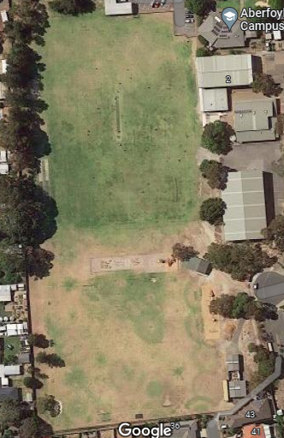
Pitch 3
Green sports Shed
COLA
Gym
Top Oval
Middle Oval
Pitch 2
Pitch 1

