Annesley Junior School Soccer 2026

Seniors Soccer Coach:
Sim - 0415 960 222
Rayan – 0447 482 384

Under 10’s Soccer Coach:
Matt – 0403 069 336

Under 8’s Soccer Coach
Rayan – 0447 482 384

Under 7’s Soccer Coach:
Susie - 0480 010 093

Sports Coordinator: Penny
rawinskip@annesley.sa.edu.au

Seniors Home Ground - 9:30am Kick Off
Field 2 - SAWSA Park, Greenhill Rd &, Peacock Rd, Adelaide SA

Under 10’s Home Ground - 8:30am Kick Off
Field 2 - SAWSA Park, Greenhill Rd &, Peacock Rd, Adelaide SA

Under 8’s Home Ground - 8:30am Kick Off
Field 1 - SAWSA Park, Greenhill Rd &, Peacock Rd, Adelaide SA

Under 7’s Home Ground - 9:30am Kick Off
Field 1 - SAWSA Park, Greenhill Rd &, Peacock Rd, Adelaide SA

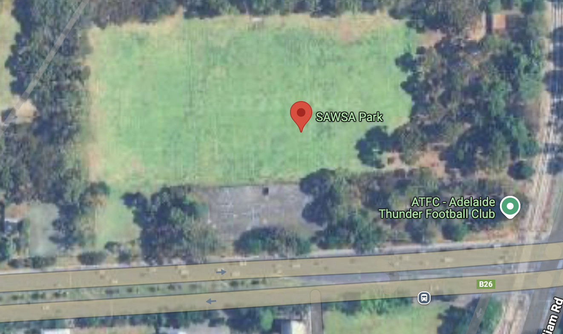
Field 2
Field 1

