Belair Primary School Game Times and Locations 2026

Under 8’s Belair Primary School – enter via Laffers Road – 10:00 am kick-off
Under 9’s Belair Primary School – enter via Laffers Road – 09:00 am kick-off

Under 10’s (White Division – Belair 1) – Frank Smith Park – Pitch 2 (smaller pitch) – 8:30 am Kick-off
Under 10’s (Blue Division – Belair 2) – Frank Smith Park – Pitch 2 (smaller pitch) – 9:30 am kick-off

Senior (Orange Division – Belair 2) – Frank Smith Park – Pitch 1– 8:30 am kick-off

Senior (White Division – Belair 1) – Frank Smith Park – Pitch 1– 9:30 am kick-off
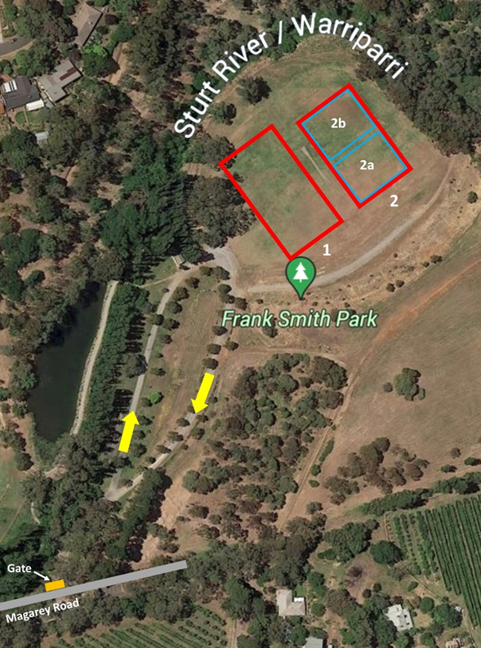
Soccer Coordinator – Laura Zafry – 0412 537 233

