
Black Forest Primary School Soccer

Location: Forest Avenue Reserve, 43 Forest Ave, Black Forest SA 5035
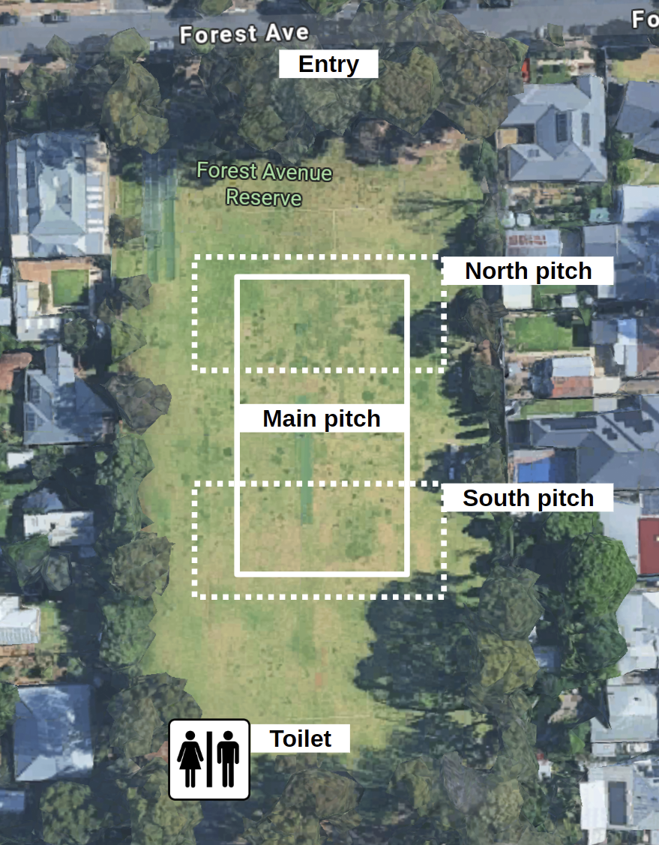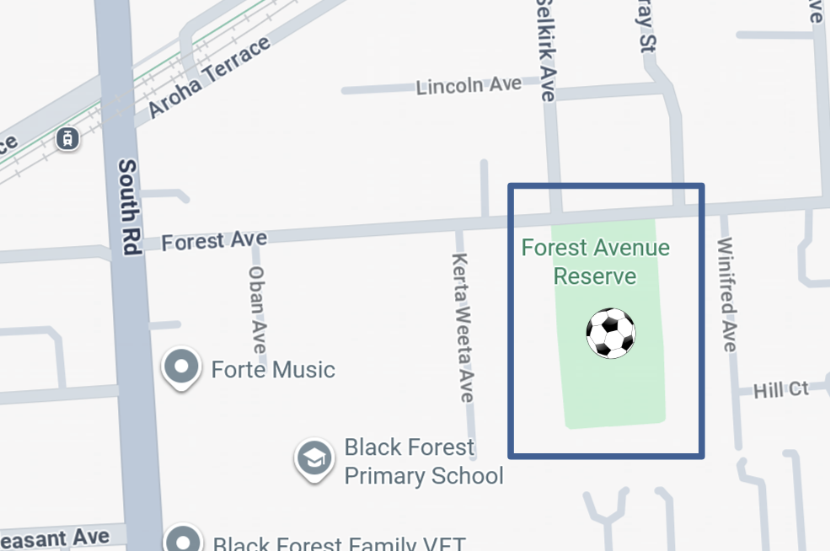
Map: https://goo.gl/maps/YfhJvyMXV6wqs8g49

Game times:
- Under 8: 8am North pitch
- Under 9: 8am South pitch
- Under 10: 9am Main pitch
- Senior White 1: 10am Main pitch
- Senior Green 2: 11am Main pitch

Shelter and toilets available in the sports pavilion at the South end of the ground.
Please be careful around the native re-vegetation areas at South-East and North-West corners of the reserve.
No dogs are allowed on the reserve.

Contact: BFPS Soccer Coordinator Mark Foreman SMS 0401677280

