Forbes Primary School 80 Thomas St, South Plympton
Kick off times:
U7s - Forbes 1: 8:30am
U7s - Forbes 2: 8:30am
U10s - Forbes 1 (White): 9:30am
U10s - Forbes 2 (Green): 10:30am
Seniors: 11:30am
Coordinator:
Alexander Beckington - 0491 138 434
Team Managers:
U7s Forbes 1: Dan - 0418 607 903 (Saturday morning only)
U7s Forbes 2: Alexander - 0491 138 434
U10s Forbes 1 (White): Amrit - 0401 807 541 (Saturday morning only)
Marion Rd.
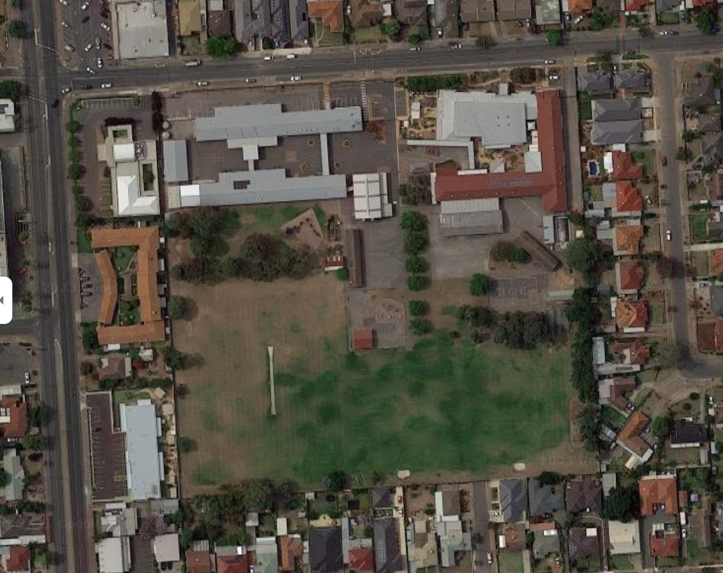
U10s Forbes 2 (Green): Aaron - 0421 285 111 (Saturday morning only)
Entrance
Playing field
Seniors: Billy - 0402 182 944 (Saturday morning only)
Thomas St.

