Ground location: Goodwood Oval Hockey Pitch, Fairfax Avenue, Millswood
Kick off | Under 7 Pitch | North pitch |  |  |  |  |  | South pitch
8.00am | U7 RED (Simon) | U8s BLUE (Laurie & Christian) |  |  | U9s BLUE (Matt)
9.00am | U7 WHITE (Tom) | U10s BLUE (Nic) |  |  | U9s GREEN (Ben & Craig)
10.00am | Full pitch | Seniors -ORANGE (Stephen)
11.00am | Full pitch | Seniors – PURPLE (Matias)
12.00pm | Full pitch | Seniors – WHITE (Morgan)
Notes:
- Please ensure all chairs and equipment are back from the line.
- No spectators please between the small Under 7 Pitch and the North Pitch (too narrow)-
(coaches and assistant referees only).
- Toilets are located below the main oval grandstand (not adjacent to the soccer pitches).
Stephen Mitchell
GPS Soccer Coordinator
0401 672 856
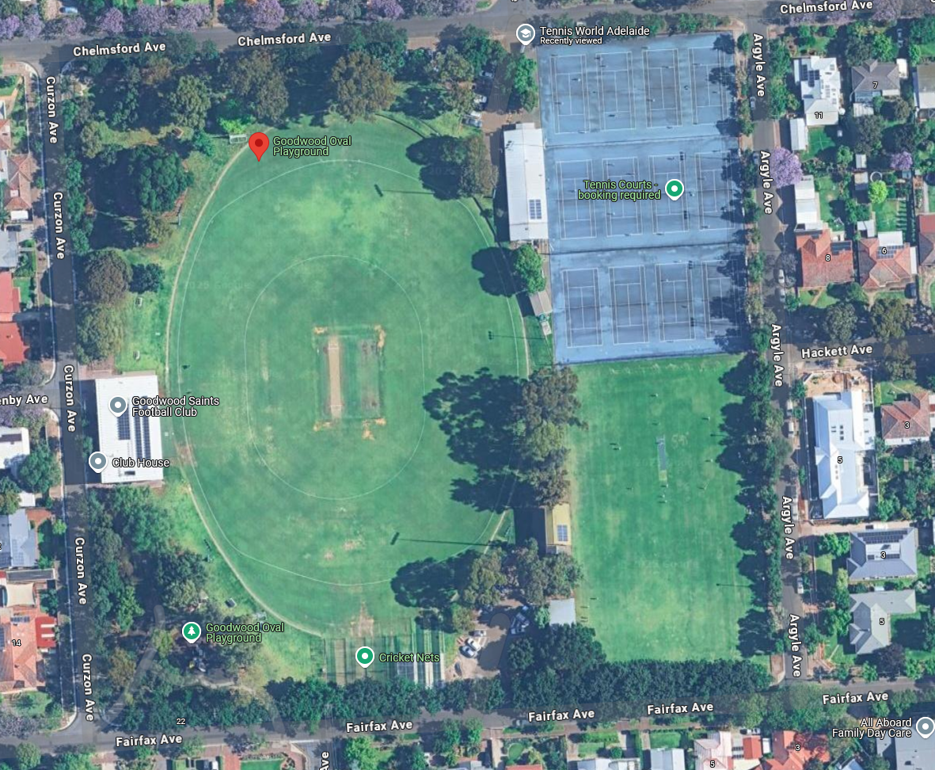
SOUTH PITCH
U7 PITCH
NORTH PITCH

