Home Games will be played on Mawson Oval on King George Avenue at Hove. Carparks are located on King George Avenue and Colton Avenue. We host a Catholic Schools R/1 Soccer competition from 8:30 – 10am every Saturday so please allow time for parking.

Medium Pitch | Large
U8 White - 8am | U10 Red – 9am
U9 Red – 9am | Senior Primary White – 10am
U9 White – 10am | Senior Primary Red – 11am

Pitch and Facilities Locations

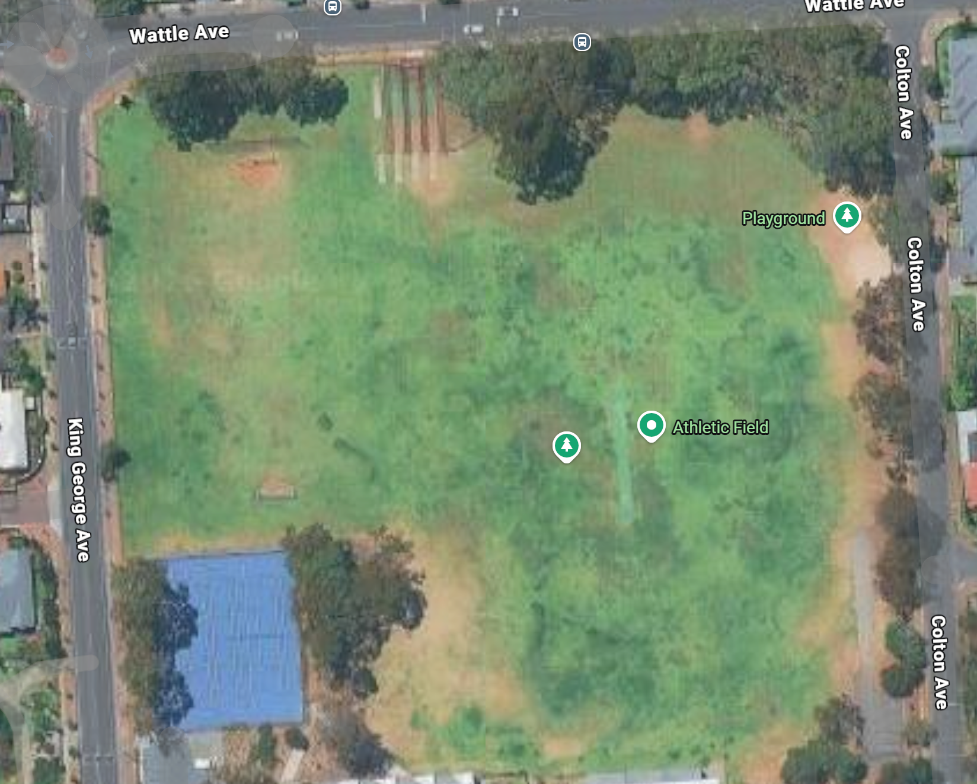
Toilet
Coffee Van
Large Pitch
Medium Pitch

School Sport Co-ordinator – Amber Robinson

Contact number - 0430 208 318

Email – amber.robinson@mcs.catholic.edu.au

