St Leonards Primary School
Glenelg North

******Please note oval entrance is off Russell Street******

Soccer Co-ordinators Rebecca Chrisan 0402 894 935
slpssoccer@gmail.com
Sarah van Eyk 0428 828 862
slpssoccer@gmail.com

2026 Game Times:
Under 7 (White) 8:00 am Pitch 2
Under 8 (Red) 8:50 am Pitch 2
Under 9 St Leonards 1 (Red) 8:50am Pitch 1
Under 9 St Leonards 2 (White) 8:00am Pitch 1
Under 10 St Leonards 1 (Red) 8:00am Pitch 3
Under 10 St Leonards 2 (Blue) 8:50am Pitch 3
St Leonards Seniors 2 (White) 10:00am Full pitch
St Leonards Seniors 1 (Red) 11:00am Full pitch

We have a coffee van, BBQ with sausages, eggs, bacon. Cash and eftpos available.

See map on next page.

Games at 8:00 am |  |  | Games at 8:50 am
U7 White – Pitch 2 |  |  | U8 Red – Pitch 2
U9 White (St Leonards 2) – Pitch 1 |  |  | U9 Red (St Leonards 1) – Pitch 1
U10 Red (St Leonards 1) – Pitch 3 |  |  | U10 Blue (St Leonards 2) – Pitch 3
Seniors games at 10:00 (White) and 11:00 (Red) on full pitch
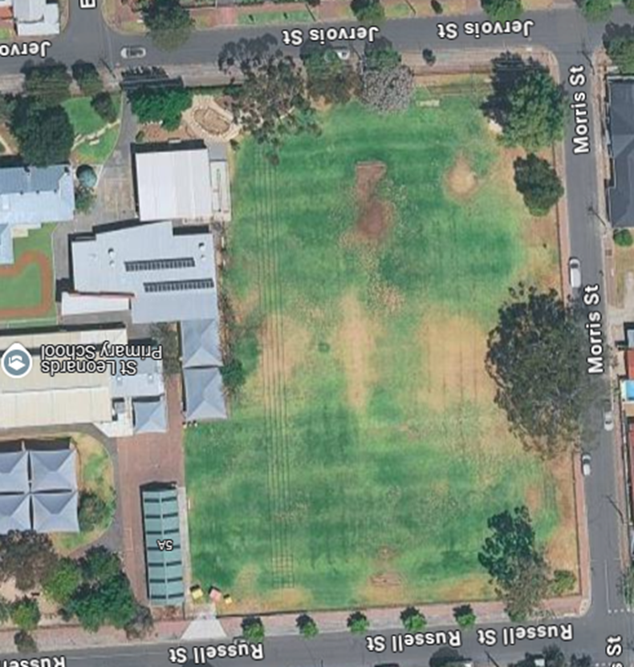
Pitch 1

---------------No standing--------------
Pitch 3

Pitch 2

