
39 Partridge Street, Glenelg

Contact Details:
Head of Sport and PE
Tom Mitton: 0435 138 037 or tmitton@spw.sa.edu.au or sports@spw.sa.edu.au

 | McKenzie Playing Field |  | Braested Playing Field
8:20 | Under 10’s – Red Competition | 8:15 | Senior Primary – Red Competition
9:10 | Under 10’s – Blue Competition | 9:15 | Senior Primary – Blue Competition
 |  | 10:15 | Senior Primary – Orange Competition

A coffee cart will be available for all home games.

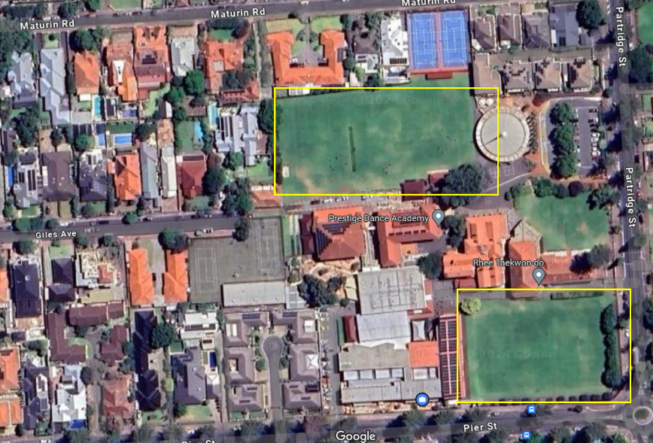

McKenzie Playing Field (near school Chapel, enter off Partridge Street)
Braested Playing Field (enter via gate on Pier Street)

