STELLA MARIS SOCCER SDJSA 2026

All home games for Stella Maris this year will be played at Darlington Primary School

School Address- 9/11 White Cres, Seacombe Gardens SA 5047

Age Group | Start | Finish
Under 8 | 8:10am | 8:55am
Under 9-Stella Maris 1 | 9:00am | 9:45am
Under 9-Stella Maris 2 | 9:50am | 10:35am
Under 10 | 10:40am | 11:35am
Senior | 11:40am | 12:30pm

Please note:
*We use 1 soccer pitch for all SDJSA home games. The goal size and pitch dimensions will remain the same for each age level (Goal size is 5x2m). There are no toilets.
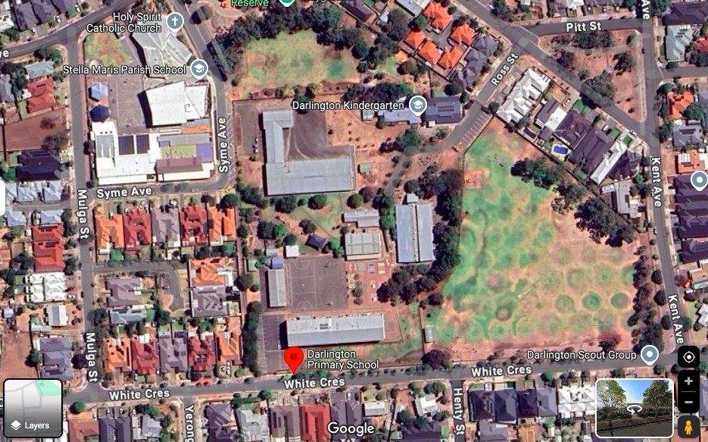

SCHOOL CONTACT
James McCarthy –
email: james.mccarthy@smps.catholic.edu.au
Mobile: 0407 114 985

